COTTON MARKET AUDIT DATA

2020-21 Cotton Season
Quantitative data is collected throughout the season for Australia’s cotton growing regions by leading crop consultants and agronomists. CCA collates an annual Cotton Market Audit dataset for industry use.
Data categories
- Seed varieties and dressings
- Plant growth regulators
- Herbicide and associated target weeds
- Insecticides and associated target pests
- Fungicides
- Adjuvants and surfactants
- Harvest aids/defoliants
Features
- Region
- Irrigated/dryland
- Gene technology
- Treatment area (hectares)
- Date of activity
- Rate, total product volume

2020-21 Season Coverage
The dataset represents 41% of Australia’s 2020-21 cotton production forecast area based on Cotton Australia estimates of June 2021.

Data Purchase
The Cotton Market Audit 2020-21 full dataset is available for purchase, or a specific query/s can be requested.

Applications
- Access current, actual field data
- Determine industry trends
- Product usage evaluation
- Develop business strategies
- Support research and development work

Data supply
- Immediate purchase and supply
- Dataset emailed in Microsoft Excel
- Concise and clearly presented
- Query presented as summary and graph
- Easily manipulated, analysed and reviewed

Cost
- $4,000 +GST for 2019-20 dataset, includes two queries.
- $2,000 +GST for historical dataset (per season)
- Partial datasets are also available. CCA can provide an estimate for specific data queries.

https://cropconsultants.com.au/cotton-data/sales-data/

Cotton Market Audit – Full Dataset Sample
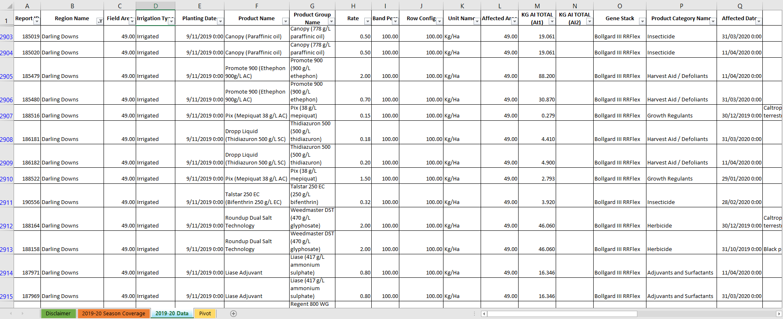

Cotton Market Audit - Query Sample
